**Experiment 1: To understand the concepts of PL/SQL programming. Objective: Students will be able to implement the basic concepts of Pl/SQL.**

1. Write a PL/SQL code to accept the value of A, B & C display which is greater.

INPUT-

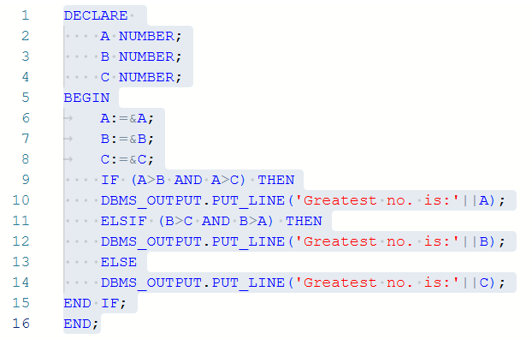

OUTPUT-

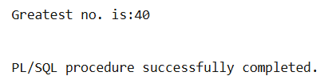

2. Using PL/SQL Statements create a simple loop that display message “Welcome to PL/SQL Programming” 20 times.

INPUT-

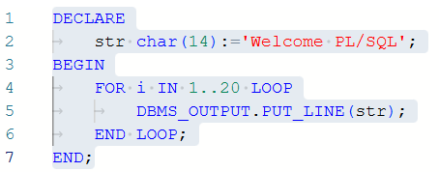

OUPUT-

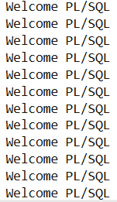 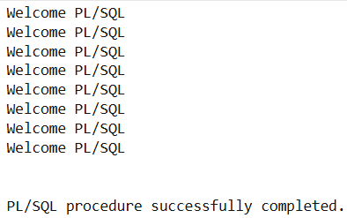

3. Write a PL/SQL code block to find the factorial of a number.

INPUT-

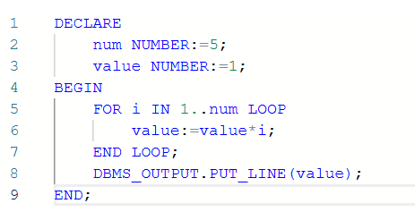

OUPUT-

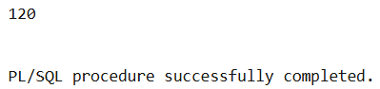

4. Write a PL/SQL program to generate Fibonacci series.

INPUT-

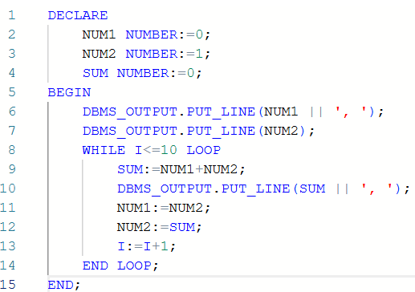

OUPUT-

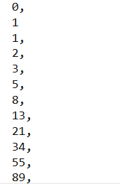

5. Write a PL/SQL code to fund the sum of first N numbers.

INPUT-

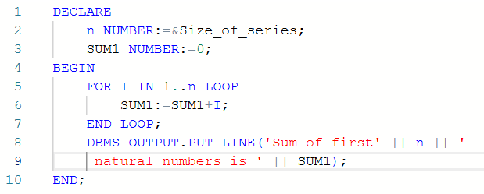

OUPUT-

